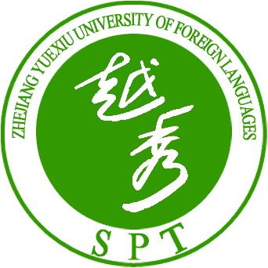
ACADEMIC ADMINISTRATION DEPARTMENT
ZHEJIANG YUEXIU UNIVERSITY OF FOREIGN LANGUAGES

Certificates
This is to certify that ____________, born on__________, is a registered student who was upgrade from junior college (two-yearfull time program) at graduate level in the Department of _____________________, major in ___________________.
Subject to the provision of Regulation of Zhejiang Yuexiu University of Foreign Languages, this student shall be hereby granted a Bachelor’s Degree on the condition that he/she fulfills all graduate qualifications.
This certificate only support the identity of school roll, but not the guarantee of graduation.

PHOTO

Web：http://jk.yxc.cn/ Fax：(0575）88343367 Postal Code：312000
Add :No.428 kuaiji Road,yuecheng District of shaoxing,Zhejiang China.

